Email Subject Line: Listen to Real Estates Hottest New Podcast - Deeds in the Desert
Hello {Recipient.FirstName},
Interested in a fresh take on all things real estate? Take a listen to Ignite Funding’s new podcast Deeds in the Desert for current market insights, risk mitigation strategies, debunking misconceptions, and so much more!
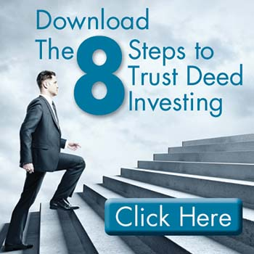

Established in 2011, Ignite Funding provides thousands of individual investors with a low barrier to entry real estate investment. This investment yields a passive, fixed-income stream collateralized by real property via a trust deed. Learn how to become a trust deed investor with our most popular whitepaper 8 Steps to Trust Deed Investing.

Consistent deal flow is hard to come by and manage on your own. Watch the President of Ignite Funding’s presentation Consistency is King to see how they provide a steady flow of investment opportunities so Ignite Funding investors can earn passive 10% to 12% annualized returns year-round.

