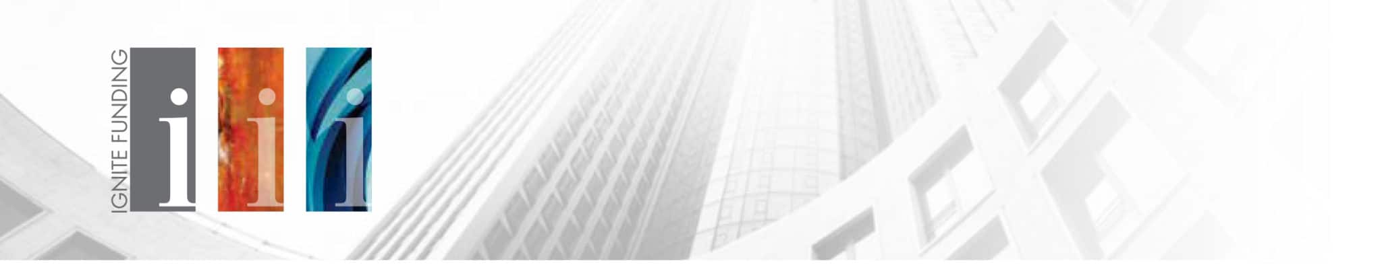
Subject Line: We’re Lending in Your Backyard, What Does That Mean for You?
Hello {recipient.firstname},
Are you an investor? Looking for passive income? Ignite Funding provides private investors with passive real estate investments that provide a 10% to 12% annualized return. That return is paid out monthly and is collateralized by real property. We think like an investor, so we know that diversification is key to any investment strategy. This is why we lend throughout the Western U.S., including hot markets like Phoenix, Arizona.
Learn more about why we are lending in your region and why you should consider it too in our article, “Hard Money Lender Moves in on Hot Phoenix Market”.
Click the button below to download the FREE article:
CTA Button “CLICK HERE” – http://info.ignitefunding.com/azr-phoenix-article-download
With low investment minimums ($10,000) and feasible suitability standards (not required to be an accredited investor), Trust Deed investments are an accessible real estate investment opportunity for all types of investors.
Check to see if we are funding a project in your local area! Ignite Funding releases several new available investments on a monthly basis so clients can easily implement portfolio diversification into their strategy. If you’re interested in learning more, text “Investments” to 844-552-7022 to schedule a 15-minute no obligation consultation.
