SDBJ EBlast #1 – 8 Steps
Subject Line: Trust Deeds: The Passive, Fixed Income You Have Been Searching For
Even the Savviest Investor May Not Know About Trust Deed Investing
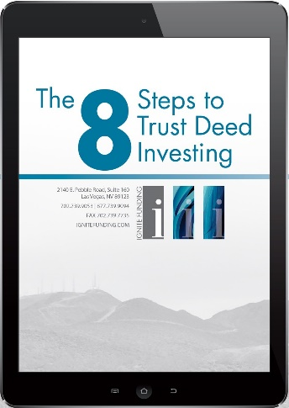
Can you name an investment where you can pull out the hammock, sit back and relax while earning annualized double-digit returns paid monthly?
No? Then let us introduce you to Trust Deed Investing with Ignite Funding. Since 2011, Ignite Funding has provided thousands of investors a way to diversify their portfolios from the stock market and into real estate investments while earning 10% to 12% annually. You may be thinking that real estate investments aren’t usually synonymous with the word ‘easy’. However, there are only 8 Steps to investing in real estate through Trust Deeds; and with Ignite Funding, you are only involved in TWO of those steps. To learn more about how to earn passive double-digit returns collateralized by real property, you can download our FREE whitepaper “8 Steps to Trust Deed Investing” by clicking the button below.
CTA Button: CLICK HERE
Ignite Funding specializes in one thing and that is collateralized real estate investments. If this topic interests you, Click Here or text “Investments” to 844-552-7022 to schedule a 15 minute no obligation consultation, and feel free to look at our current available investments. We hope to have you investing and earning double-digit returns soon!
