July 2021 Eblast
Subject Line: Trust Deeds: A Passive Fixed Income Stream - FREE Zoom Seminar
Hello {recipient.firstname},
Are you interested in earning passive double-digit returns in real estate investments that are secured by real property, but don’t have hours of free time to learn how to do it yourself? At Ignite Funding we think like an investor, which is why we have put together a quick 30 minute presentation with live Q&A to tell you what you need to know about Trust Deed investing and answer your questions in real time.
Join us next week for a FREE virtual event hosted by Dawn Pitts via Zoom video conferencing on August 3rd, 2021 at 9:00AM PST.
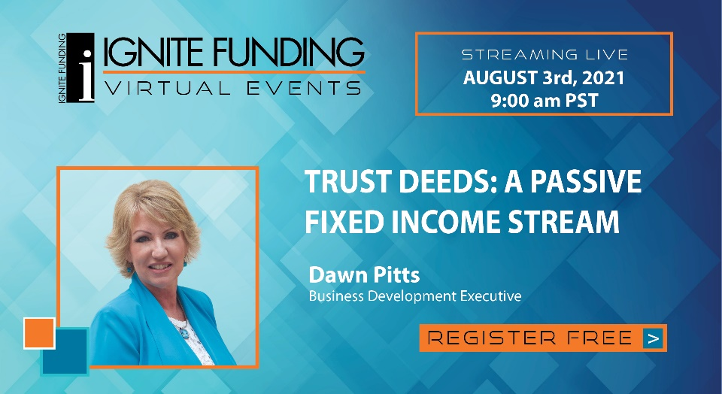
Put a face to the name while learning how you can earn 10% to 12% annualized returns with Trust Deeds, what you are investing in, and how Ignite Funding is different from the competition.
The morning of the event we will send you a link that will take you directly to where the Zoom meeting will be hosted. Important Note: Please make sure you already have the Zoom app downloaded on your computer or to your smartphone so you don't show up late and miss any important information.
Click the button below to RSVP now for this free virtual event:
CTA “RSVP HERE” Link to: http://info.ignitefunding.com/dpitts-landing-rsvp
Unable to attend the event on that date? CLICK HERE to schedule a one-on-one Zoom session at a time that works best for you.
