LVRJ Sponsored Content - April 2021
Subject Line: Investors - Is Your Tax Sheltering Strategy Bulletproof?
Regardless of whether you invest in the conventional market or you participate in more sophisticated investments like real estate, we are all sitting in a world of unknowns right now. All politics aside, there are a couple things that are certain. First and foremost, at the end of the day, the trillions of dollars that will have been issued for pandemic relief will need to be paid back. Secondly, it can generally be agreed upon that the recourse for those relief dollars will be through taxes. The underlying question here is, what measures are you taking in preparation of this impending tax event?
Do you only have tax shelters in place for your personal income? Business owners, do you have tax shelters in place for your company’s income? Are you only sheltering your conventional investments and not your alternative investments, like real estate?
The government has granted you the boon of many forms of tax sheltering vehicles, including the Self-Directed IRA (SDIRA). It is no secret, and yet Self-Directed IRAs are still one of the most underutilized vehicles for tax relief on alternative investments by new and even seasoned investors! SDIRAs are available for individuals in the form of Traditional or Roth IRAs and Solo 401ks, and for the entrepreneurs/business owners with SEP and SIMPLE IRAs.
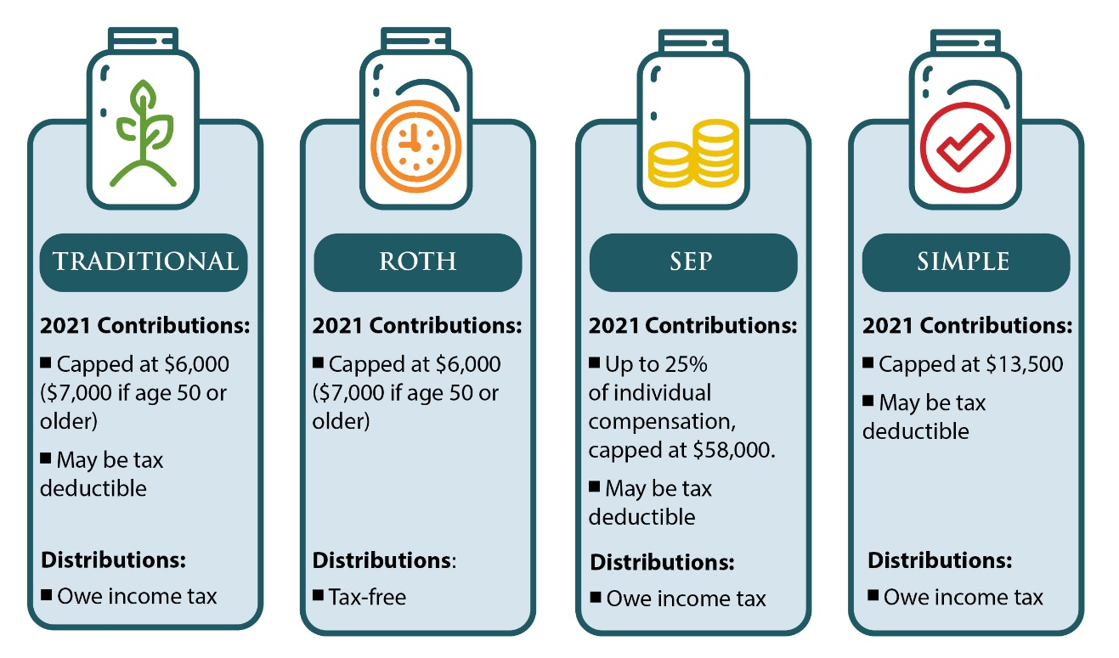
Since its inception in 2011, Ignite Funding has empowered thousands of investors to invest in turnkey real estate investments via Trust Deeds within a SDIRA. Trust Deeds investments are highly regulated, have shorter hold periods, lower investment minimums, offer capital preservation, are generally passive, and deliver a fixed income, making it an ideal investment to deploy in a retirement portfolio. Investors utilizing a SDIRA can compound 10% to 12% annualized returns tax-deferred or tax-free, depending on the account. Let’s put it into perspective by breaking down the numbers for investing with cash versus investing with qualified funds.
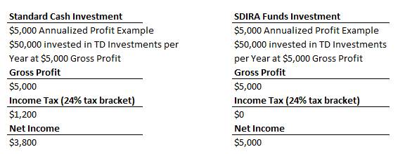
As you can see, that is a significant amount of interest income that is sheltered from taxes and can help supplement the growth of your retirement nest egg. With enough foresight, the Trust Deed investment’s ability to generate a fixed, monthly income can also be used to help bridge the income gap during your retirement years.
The primary problem that many retirees face is how to replace the income they used to earn from their job. Sources of income from pensions, social security, disability, and income properties may still not be enough; and, unfortunately, not a lot of thought is given to creating a strategy on how to effectively use the retirement assets once we reach those latter stages of life. Imagine if you could take $120,000 from a retirement account and generate $1,000 per month of income in perpetuity without spending a dime of the $120,000. Sounds too good to be true, right? To learn more about this strategy, you can Click Here to download our FREE whitepaper “Building-up vs. Drawing Down: An IRA Income Strategy”.
So, can you say you are doing everything you can to protect your hard-earned assets? If you can’t answer this question with confidence, you could be overdue on a visit with your tax advisor to discuss your options. To learn more about investing in Trust Deeds with a Self-Directed IRA, you can call Ignite Funding at 702-761-0000 or Click Here to schedule a 15 minute no obligation consultation.
Ignite Funding, LLC | 2140 E. Pebble Road, Suite 160, Las Vegas, NV 89123 | P 702.739.9053 | T 877.739.9094 | F 702.922.6700 | NVMBL #311 | AZ CMB-0932150 | Money invested through a mortgage broker is not guaranteed to earn any interest and is not insured. Prior to investing, investors must be provided applicable disclosure documents.

