April 2021 Eblast
Subject Line: Now’s Your Chance to Earn Passive Income - FREE Zoom Seminar
Hello {recipient.firstname},
Are you interested in earning passive double-digit returns in real estate investments that are secured by real property? Do you really want to get to know who you are investing with before you pull the trigger? Then let us introduce you to Trust Deed investments at Ignite Funding!
Join us next week for a FREE virtual event hosted by Howard Robbins via Zoom video conferencing on Tuesday, May 4th at 9AM PST.
Put a face to the name while learning WHY NOW is the right time to invest in real estate with Ignite Funding. Learn how you can earn 10% to 12% annualized returns with Trust Deeds, what you are investing in, and how Ignite Funding is different from the competition.
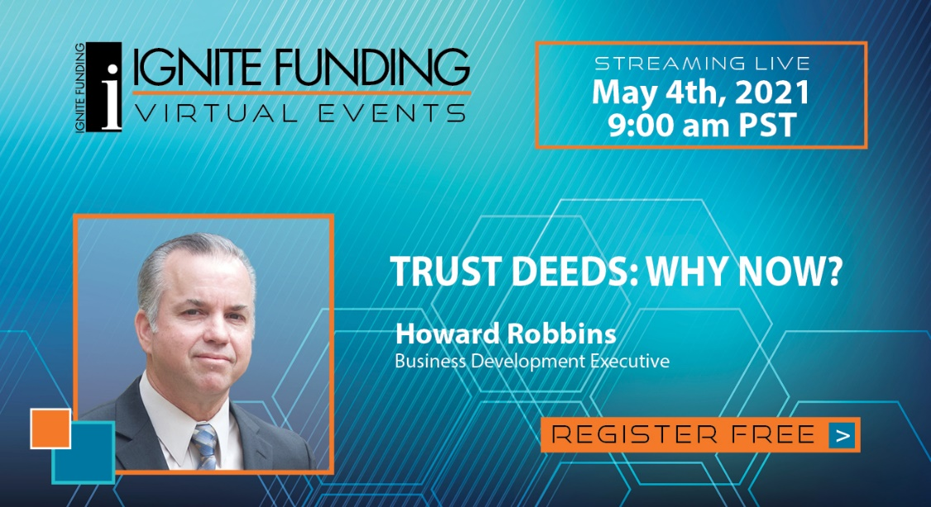
The morning of the event we will send you a link that will take you directly to where the Zoom meeting will be hosted. Important Note: Please make sure you already have the Zoom app downloaded on your computer or to your smartphone so you don't show up late and miss any important information.
Click the button below to RSVP now for this free virtual event:
CTA “RSVP HERE” Link to: http://info.ignitefunding.com/hrobbins-landing-rsvp
Unable to attend the event on that date? CLICK HERE to schedule a one-on-one Zoom session at a time that works best for you.
