Subject Line: Three Words: Passive, Fixed, Income. Need We Say More? – Ignite Funding

Hello {Recipient.FirstName},
Have you ever considered investing in real estate but were discouraged by the amount of work or the amount of capital you would need to be successful? With Trust Deeds at Ignite Funding, there are only 8 Steps to investing in real estate, and only TWO of those steps involve you. With just TWO STEPS and a low barrier to entry, you can reap the benefits of double-digit returns and real property as collateral without the headache of all the extra work nor the stress of investing more than what you bargained for – it's as easy as completing a set of documents.
Trust Deed Investment Benefits:
- 10% to 12% annualized returns
- Passive, fixed income
- Collateralized by real property
- Always serviced in-house from start to finish
EXCLUSIVE: Interested in learning more? Click the image below to receive an exclusive bundle of our three most popular whitepapers, “8 Steps to Trust Deed Investing”, “Understanding Compounding Interest”, and “5 Misconceptions of Trust Deed Investing”.
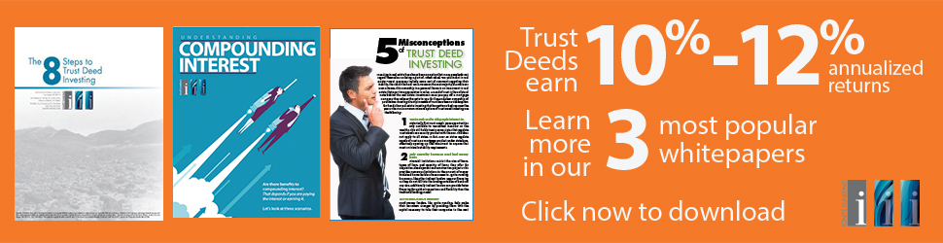
Link image to: http://info.ignitefunding.com/rj_emailblast-2020-0

Ignite Funding
Website: www.ignitefunding.com
2140 E Pebble Rd, Suite 160
Las Vegas, NV 89123
P: 702.739.9053
