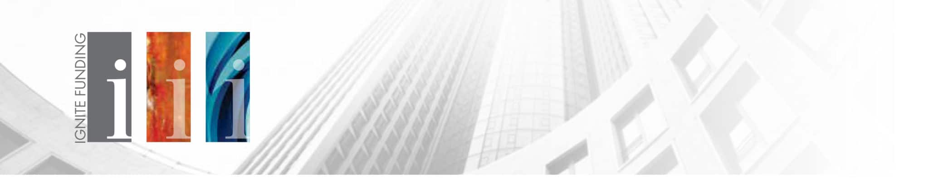
Subject Line: New Opportunity! Earn 10% to 12% Investing in Your Own Backyard
Hello {Recipient.FirstName},
Are you earning double-digit annualized returns on your investments? Do you want to invest in your community? With Trust Deed investments at Ignite Funding, you have the opportunity to accomplish both! Over the course of 10 years in the lending industry, Ignite Funding has paid out over $60 million in interest income to investors and has funded over $846 million in real estate projects. Ignite Funding originates and services every Trust Deed investment, making this a passive investment with fixed income.
LIMITED AVAILABILITY!
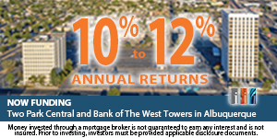
Our latest investment opportunity is located in Albuquerque, New Mexico with the acquisition of two landmark office buildings located off of San Mateo Blvd and Route 66. The developer will utilize Ignite Funding’s financing to acquire the property, upgrade one of the office buildings, and then reposition its current tenants, including the New Mexico Department of Health, to the upgraded building. This will completely vacate the other office building on the property, with which the borrower will convert into an approximately 150-unit apartment building. The developer has already executed a similar strategy in the Albuquerque area with a hotel conversion into apartments. Investors will have the opportunity to invest in this project, earning them 10% annualized interest with the two office buildings collateralizing their investment.
To learn more about investing in this project click the button below:
CTA Button linked to - http://info.ignitefunding.com/albuquerque-towers
